

**Master of Science in Computing and Data Analytics**

**Statistics and it’s Application in Business**

**MCDA 5520**

**Group Project on Mental Health of University Students**

Under the supervision of

**Dr. Michael Zhang**

**Submitted By:**

|  |  |  |
| --- | --- | --- |
| **Name** | **A#** | **Email** |
|  |  |  |
| Jasmeet Singh  Jiye Wang | A00433036  A00426401 | [Jasmeet.Singh@smu.ca](mailto:Jasmeet.Singh@smu.ca)  [Jiye.Wang@smu.ca](mailto:Jiye.Wang@smu.ca) |
| Goutham Bommu | A00432541 | [Goutham.bommu@smu.ca](mailto:Goutham.bommu@smu.ca) |
| Saranjyot Singh | A00432530 | [Saranjyot.Singh@smu.ca](mailto:Saranjyot.Singh@smu.ca) |
| Chaitanya Varma  Hemanchal Joshi | A00432282  A00433394 | [Chaitanya.varma.mudundi@smu.ca](mailto:Chaitanya.varma.mudundi@smu.ca)  [Hemanchal.Joshi@smu.ca](mailto:Hemanchal.Joshi@smu.ca) |

**Table of Contents**

**1.** **Introduction** 3

**2.** **Objectives** 3

**3.** **Major Problem Solving** 3

3.1. Question 1 3

3.1.1. Methods Used 3

3.1.2. Analysis 4

3.1.3. Results 6

3.2. Question 2 7

3.2.1. Methods Used 7

3.2.3. Assumptions: 7

3.2.3. Results 11

3.3. Question 3 12

3.3.1. Methods Used 12

3.3.2. Analysis 12

3.3.3. Results 18

3.4. Question 4 18

3.4.1. Methods Used 19

3.4.2. Procedure 19

3.4.3. Results 20

**4.** **Conclusion** 21

**5.** **References** 21

# **Introduction**

This project is to make analysis on the mental health condition of the students in Saint Mary’s University. The data is retrieved from two phases of the surveys. The first phase of survey is on five fields which are the knowledge of mental health (A), the stigma (B), the attitudes towards help seeking (C), the general mental health (D) and perceived stress (E). Then the participants were given a material of **142 pages of *Transitions*** content to read in several weeks. The second phase of survey were conducted after that on three fields which are the knowledge of mental health (A), the stigma (B) and the attitudes towards help seeking (C).

# **Objectives**

The objectives of the overall analysis of the project are as following:

* To understand the general mental health conditions of the university students in five fields mentioned previously.
* To find out how the mental health conditions in five fields are influenced by various factors including gender, nationality, culture, first language and school year.
* To find out the effectiveness of the intervention of ***Transitions*** on three fields mentioned previously and how it is influenced by factors above.
* To predict on the mental health conditions on three fields mentioned previously based on factors above.
* To find out important insights based on the answers of the participants on several crucial questions.

# **Major Problem Solving**

From the given set of descriptions and data provided for the project, the focus was shifted on the major sectors for analysis. After going through the whole document and categorizing the topics to analyze, five major questions were taken into consideration to analyze the available data and extract a conclusion from them. The questions are taken as a base and various attributes are analyzed using various analysis tools and methods.

**3.1. Question 1**

**How to evaluate the general health conditions including knowledge, stigma and attitude based on nationality and gender?**

### **3.1.1. Methods Used**

The main methods used for analysis are

* **General descriptive analysis** on knowledge (A), stigma (B), help-seeking attitude (C), health (D), stress (E)
* **Detailed descriptive analysis** on knowledge (A), stigma (B), help-seeking attitude (C), health (D), stress (E) based on gender, location, experience
* **Chi-square** to know whether gender(location/experience) makes a difference
* **Contingency table** and **post-hoc** to combine two factors once at a time.

### **3.1.2. Analysis**

The analysis was done on the basis of methods mentioned above.

**Attribute: Knowledge**

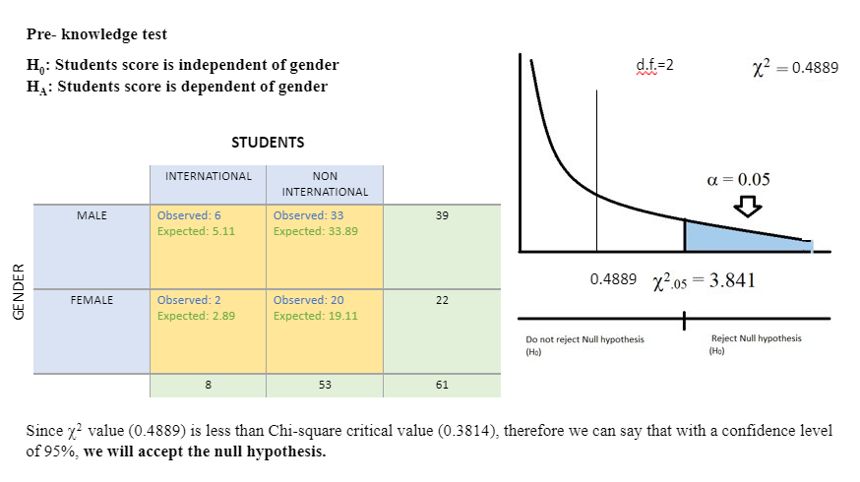

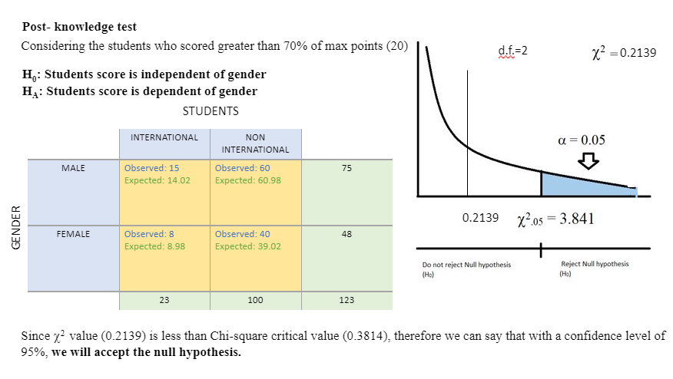

**Attribute: Stigma**

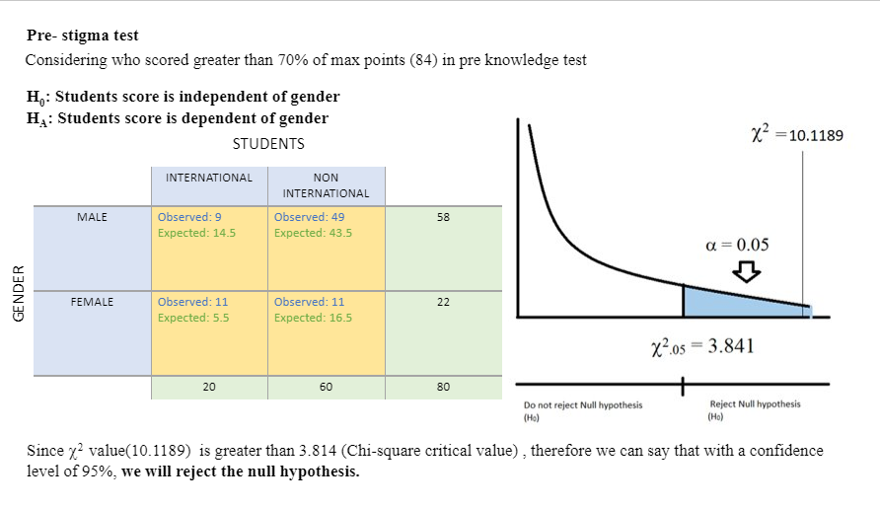

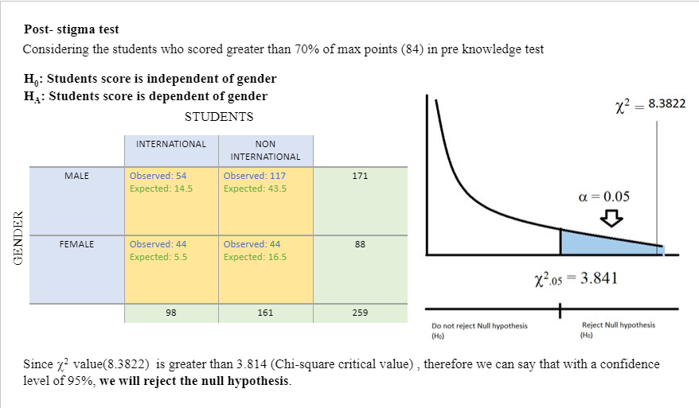

**Attribute: Help**

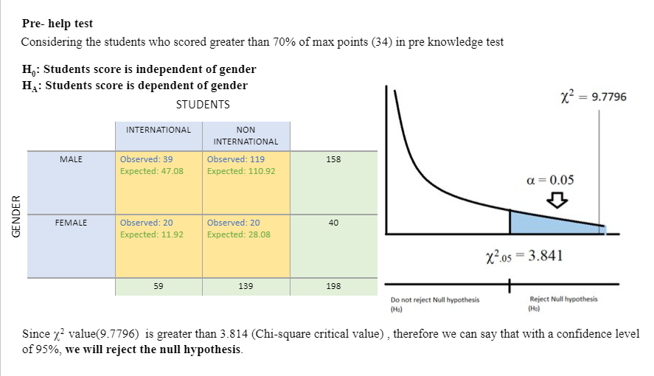

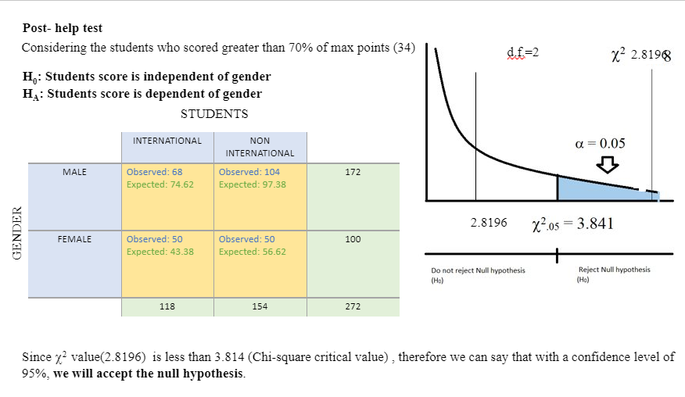

### **3.1.3. Results**

From this, we conclude that students attitude towards asking help has changed after transition.

**3.2. Question 2**

**Are language and school year huge factors on the stigma and help-seeking attitude?**

### **3.2.1. Methods Used**

The main methods used for analysis are

* + **Data Cleaning** i.e. Separate the data into English and Non-English speakers, First Year (Only bachelor’s degree) and More than First Year
  + **Descriptive analysis** on stigma (B), help-seeking attitude (C)
  + **Chi-square** to know whether language/school year makes a difference
  + **Contingency table** to combine two factors.

### **3.2.3. Assumptions:**

As the high scorers are considered to show a positive attitude, so to categorize the students showing positive and negative attitude we have taken above 70% scoring students as showing Positive attitude whereas less than 70% scoring students as exhibiting Negative attitude.

**3.2.2. Analysis**

**Descriptive Analysis**

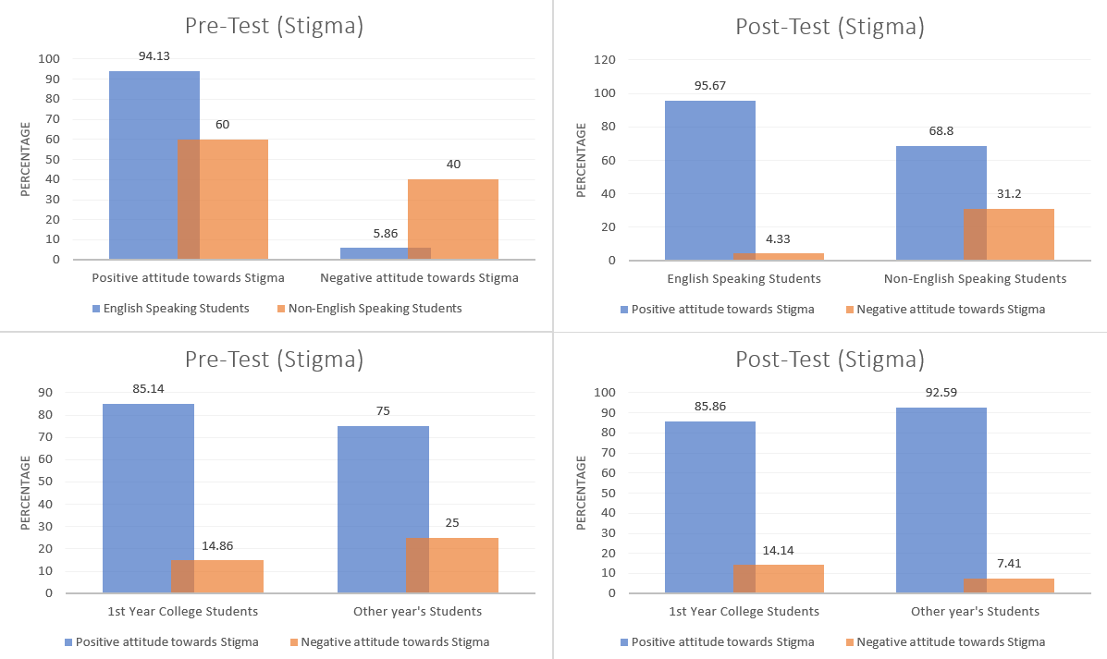

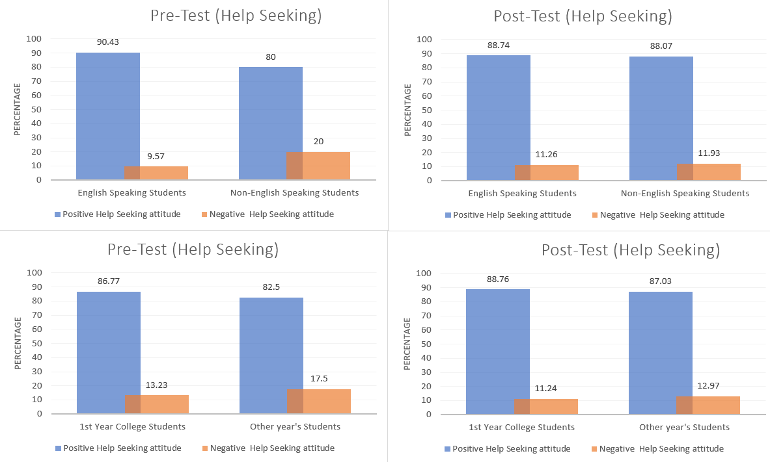

* **Pre Test (Stigma),** taking Language as a factor

**H0: Language was not a factor in having Positive attitude towards Stigma.​**

**HA: Language was a factor in having Positive attitude towards Stigma.​**

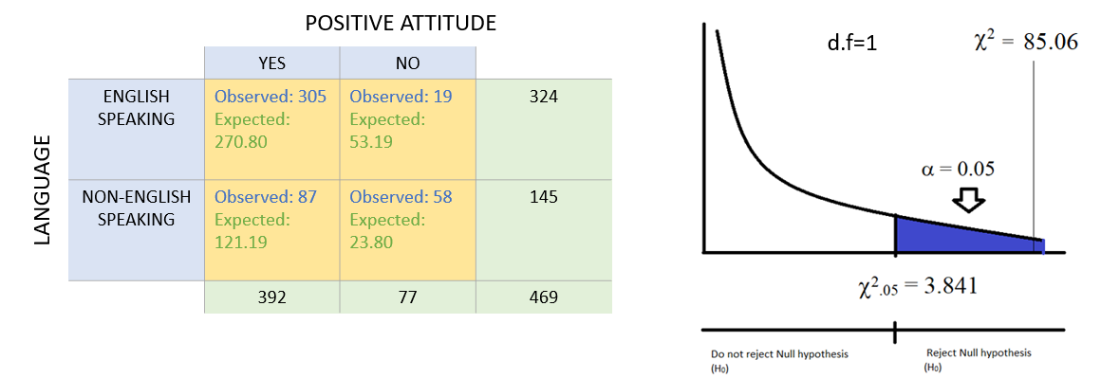

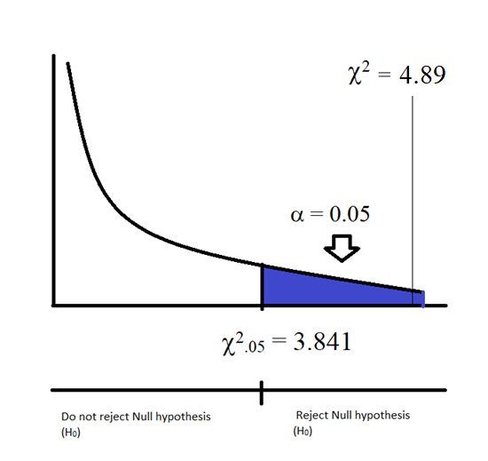

Since chi-square value is greater than 3.841, as well as the p-value =0.00001 therefore we can say that the result is significant at p<0.05​. **Thus, we will reject the null hypothesis.**

* **Post-Test (Stigma) ,** taking Language as a factor

**H0: Language was not a factor in having Positive attitude towards stigma. ​**

**HA: Language was a factor in having Positive attitude towards stigma. ​**

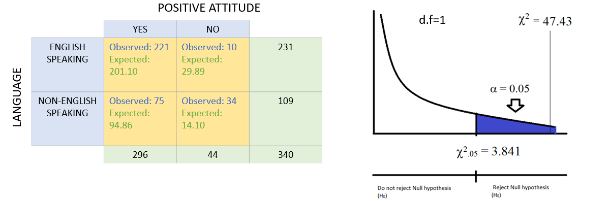

Since chi-square value is greater than 3.841, as well as the p-value =0.00001 therefore we can say that the result is significant at p<0.05​. **Thus, we will reject the null hypothesis.**

* **Pre Test (Stigma),** taking College Year as a factor

**H0: College Year was not a factor in having Positive attitude towards Stigma.​**

**HA: College Year was a factor in having Positive attitude towards stigma. ​**

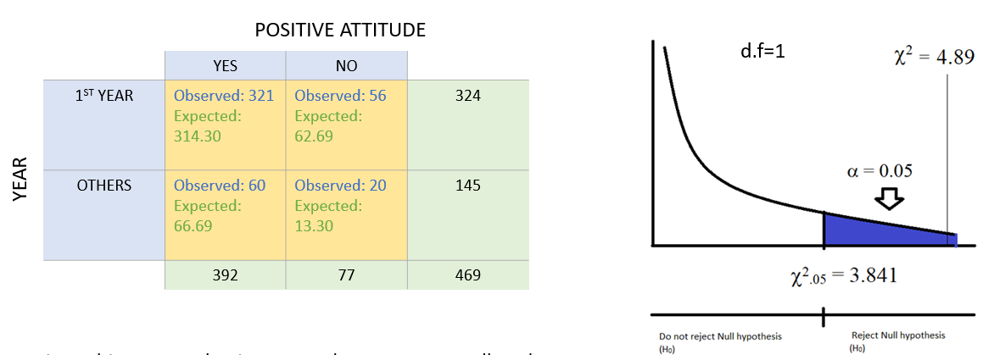

Since chi-square value is greater than 3.841, as well as the p-value =0.026 therefore we can say that the result is significant at p<0.05​. **Thus, we will reject the null hypothesis.**

* **Post-Test (Stigma) ,** taking College Year as a factor

**H0: College Year was not a factor in having Positive attitude towards Stigma.​**

**HA: College Year was a factor in having Positive attitude towards Stigma.​**

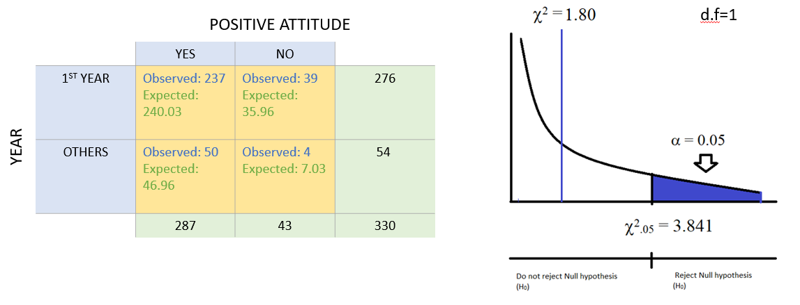

Since chi-square value is less than 3.841, as well as the p-value =0.1795 therefore we can say that the result is not significant at p<0.05​. **Thus, we will not reject the null hypothesis.**

* **Pre Test (Help Seeking),** taking Language as a factor

**H0: Language was not a factor in having Positive Help-seeking attitude.​**

**HA: Language was a factor in having Positive Help-seeking attitude.​**

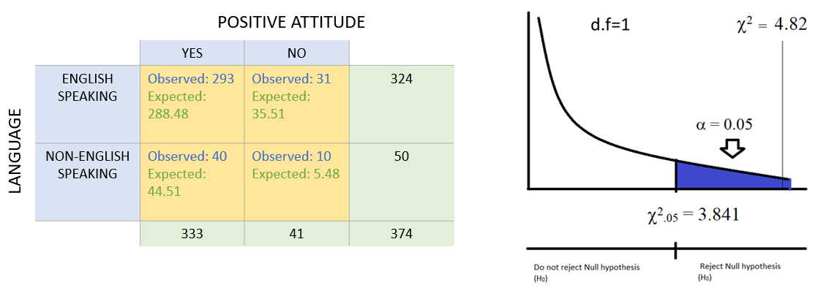 Since chi-square value is greater than 3.841, as well as the p-value =0.2797, therefore we can say that the result is significant at p<0.05​. Thus we will reject the null hypothesis.

* **Post Test (Help Seeking),** taking Language as a factor

**H0: Language was not a factor in having Positive Help-seeking attitude.​**

**HA: Language was a factor in having Positive Help-seeking attitude.​**

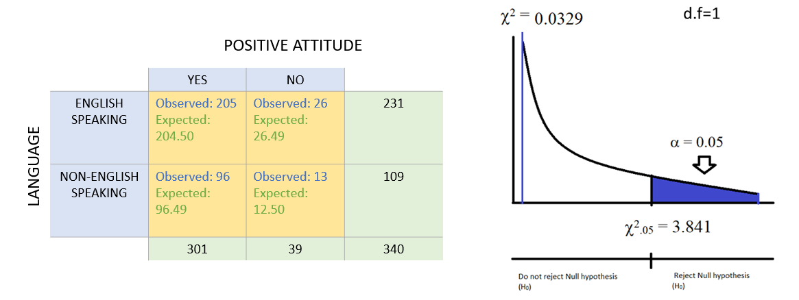

**Since chi-square value is less than 3.841, as well as the p-value =0.8561, therefore we can say that the result is not significant at p<0.05**​. Thus, we will not reject the null hypothesis.

* **Pre Test (Help Seeking),** taking College Year as a factor

**H0: College year was not a factor in having Positive Help-seeking attitude.​**

**HA: College year was a factor in having Positive Help-seeking attitude.​**

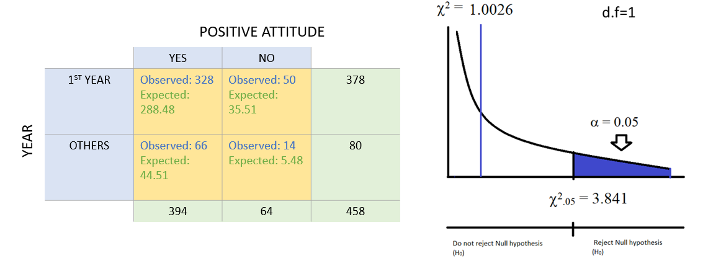

Since chi-square value is less than 3.841, as well as the p-value =0.31668, therefore we can say that the result is not significant at p<0.05**​. Thus, we will not reject the null hypothesis.**

* **Post Test (Help Seeking), taking College Year as a factor**

**H0: College Year was not a factor in having Positive Help-seeking attitude.​**

**HA: College Year was a factor in having Positive Help-seeking attitude.​**

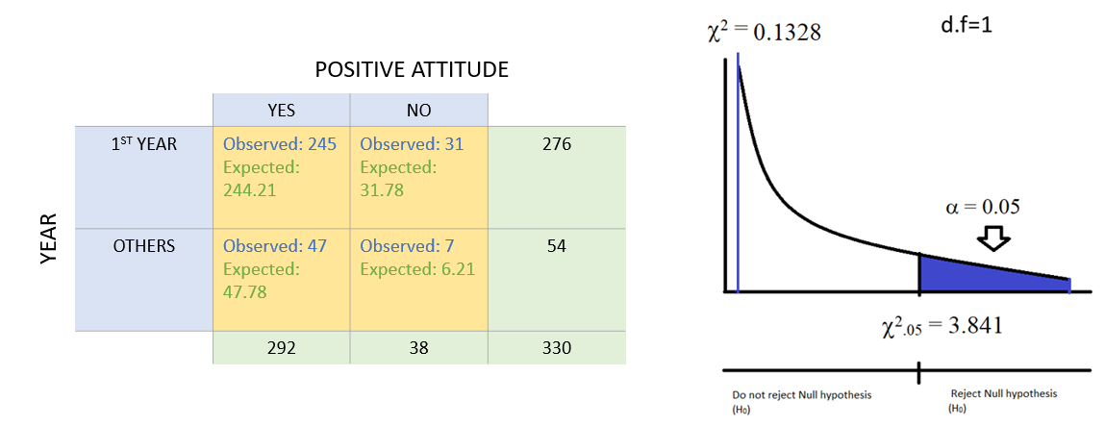

Since chi-square value is less than 3.841, as well as the p-value =0.7155, therefore we can say that the result is not significant at p<0.05​. **Thus, we will not reject the null hypothesis.**

### **3.2.3. Results**

In the stigma for mental health help seeking, first language and school year are indeed important factors. It is 95% confident that students with first language other than English and fresh students on the first year have fewer positive attitudes. But the school year is no longer a factor after the ***Transitions*** while first language remains the same. In the attitude towards mental health help seeking, first language was initially a factor but become less important after the Transitions while school year is not a factor in both pre-transitions and post-transitions phases.

**3.3. Question 3**

**Is culture (ethnicity) a huge factors on the effectiveness of transitions?**

The cultural background can have great influence on the effectiveness of the ***Transitions*** content on Knowledge (A), Stigma (B) and Attitudes (C). Three major ethnicities are selected to conduct the analysis to find out whether cultural backgrounds indeed influence the effectiveness. The three major ethnicities are Canadian (0), Caucasian (1) and Chinese (2). And the numbers of records are 64, 44 and 53 respectively.

### **3.3.1. Methods Used**

The main methods used for analysis are:

* **Descriptive Analysis**
* **Conduct the Analysis of Covariances**
* **Post Hoc Tests**

### **3.3.2. Analysis**

**Attribute: Knowledge**

From the descriptive analysis, we can know that the average total knowledge scores of Chinese are less than other two ethnicities in both pre and post phases. Also, the average total scores on mental health knowledge of all three ethnicities increased significantly and the increase in Chinese ethnicity is the most.



In ANOVA test, the F values of Pre_Knowtotal and Post_KnowTotal are large enough with 49.723 and 30.013 respectively (decreasing) and the Sig values are close to 0. As a result, we can come to the conclusion that there are significance differences between the three ethnicities in both pre-transitions survey and post-transactions survey on total score of mental health knowledge.

Pre-knowtotal:

**H0: The mean scores of all the ethnicity groups are equal**

**H1: The mean scores of ethnicity groups are unequal**

Post-knowtotal:

**H0: The mean scores of all the ethnicity groups are equal**

**H1: The mean scores of ethnicity groups are unequal**



The result of the post hoc test on scores of knowledge shows that the sig values between Canadian and Caucasian in pre-transitions survey and post-transitions survey are 0.281 and 0.645 respectively. Accordingly, there is no significant difference between these two ethnicities in both phases of surveys. At the same time, the sig values between Chinese and each of other two ethnicities in both pre and post phases are close to 0. So, there are significance differences between Chinese and each of other two ethnicities in both phases.

**Result:**

**Pre & Post know**: As the p <0.05 we reject the null hypothesis and select alternative hypothesis.

To analyze further we performed Tukey HSD post hoc. To identify the group that is causing us to reject null hypothesis.



From post hoc analysis in pre and post knowledge it is clearly evident that group 3 that is Chinese has mean that is varying from the other two groups.

**Attribute: Stigma**

From the descriptive analysis, we can know that the average total stigma scores of Chinese are less than other two ethnicities in both pre and post phases. Also, the average total scores on stigma of all three ethnicities increased slightly. The scores of Canadian and Caucasian in both phases are close to the highest score of 84.



In ANOVA test, the F values of Pre_stigmatotal and Post_stigmaTotal are significantly large with 125.870 and 87.079 respectively (decreasing) and the Sig values are close to 0. As a result, we can come to the conclusion that there are significance differences between the three ethnicities in both pre-transitions survey and post-transactions survey on total score of the stigma for receiving mental health.

Pre-stigmatotal:

**H0: The mean scores of all the ethnicity groups are equal**

**H1: The mean scores of ethnicity groups are unequal**

Post-stigmatotal:

**H0: The mean scores of all the ethnicity groups are equal**

**H1: The mean scores of ethnicity groups are unequal**



The result of the post hoc test on scores of stigma shows that the sig values between Canadian and Caucasian in pre-transitions survey and post-transitions survey are 1 and 0.689 respectively. Accordingly, there is no significant difference between these two ethnicities in both phases of surveys. At the same time, the sig values between Chinese and each of other two ethnicities in both pre and post phases are close to 0. So, there are significance differences between Chinese and each of other two ethnicities in both phases.

**Result:**

**Pre & Post stigma:** As the p <0.05 we reject the null hypothesis and select alternative hypothesis.

To analyze further we performed Tukey HSD post hoc. To identify the group that is causing us to reject null hypothesis.



From post hoc analysis in pre and post stigma it is clearly evident that group 3 that is Chinese has mean that is varying from the other two groups

**Attribute: Help**

From the descriptive analysis, we can know that the average total help seeking attitude scores of Chinese are less than other two ethnicities in both pre and post phases. However, the average total scores of Canadian and Caucasian decreased significantly after ***Transitions***. Only the average total score of Chinese increased slightly.



In ANOVA test, the F value of Pre_helptotal is 3.187 and the Sig value is 0.044 which is slightly less than 0.05. As a result, we can come to the conclusion that there are significant differences between the three ethnicities in pre-transitions survey on total score of the attitudes towards mental health help seeking. However, the F value of Post_helptotal is 0.720 and the Sig value is 0.488 which is much larger than 0.05. So, there isn’t significant difference between the three ethnicities in post-transitions survey.

Pre-help:

**H0: The mean scores of all the ethnicity groups are equal**

**H1: The mean scores of ethnicity groups are unequal**

Post-help:

**H0: The mean scores of all the ethnicity groups are equal**

**H1: The mean scores of ethnicity groups are unequal**



The result of the post hoc test on scores of help seeking attitude shows that all the comparisons in both per-transitions and post transitions survey, only the sig value between Canadian and Chinese in pre-transitions survey is slightly less than 0.5 with 0.040. Accordingly, significant difference only exists between these two ethnicities in pre-transitions phases of surveys.

**Result:**

**Pre _help:** As the p <0.05 we reject the null hypothesis and select alternative hypothesis.

To analyze further we performed Tukey HSD post hoc. To identify the group that is causing us to reject null hypothesis.



From post hoc analysis in pre_help it is clearly evident that group 3 that is Chinese has mean that is varying from the other Caucasian.

### **3.3.3. Results**

Ethnicity plays an important role in the mental health knowledge and the stigma for mental health help seeking in both pre-transitions and post transitions phases. The main difference is between Chinese and other two ethnicities. After the ***Transitions***, however, the overall performance on knowledge of three major ethnicities increases and the stigma becomes more positive. Besides, the difference between three ethnicities decreased.

But in attitude towards mental health help seeking, the Transitions has negative influence on Canadian and Caucasian ethnicities while Chinese became more positive after the Transitions. The only difference between Chinese and Canadian disappeared after the Transitions.

**3.4. Question 4**

**Can the stigma in post-transitions phase be predicted based on the ethnicity, gender, language, pre-transitions knowledge, stigma and attitudes as well as school year?**

After conducting descriptive as well as inferential statistics on the pre-as well as post transition phases, we wanted to utilize the insights effectively to predict the stigma total of the students participating in it.

### **3.4.1. Methods Used**

* Using pandas library in python for data wrangling
* Using **polynomial regression model** (stepwise), we conducted **multivariate regression** with attributes like the language, gender, stigma, help-seeking attitudes scores for predicting the post stigma

### **3.4.2. Procedure**

* We **imported** the pre and post phase **data** for the common students present in both the phases from the excel

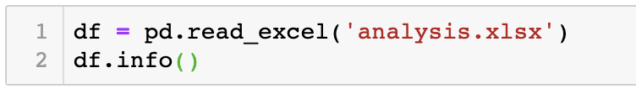

* With help of the **correlation coefficients** we dropped the unwanted extra attributes

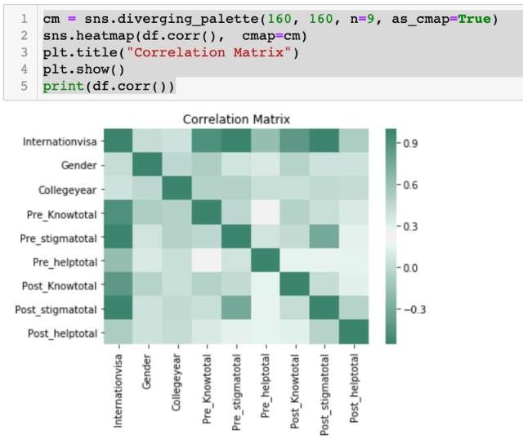

* As the data we were left with was just 340 rows we decided to **fill null attributes** with the forward fill method
* **Transformed** the text labels into numbers using the **label encoders** and **added** the **dummy variables**

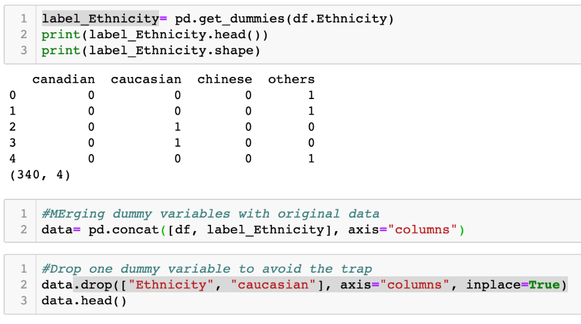

* **Split the data** set into training and testing data

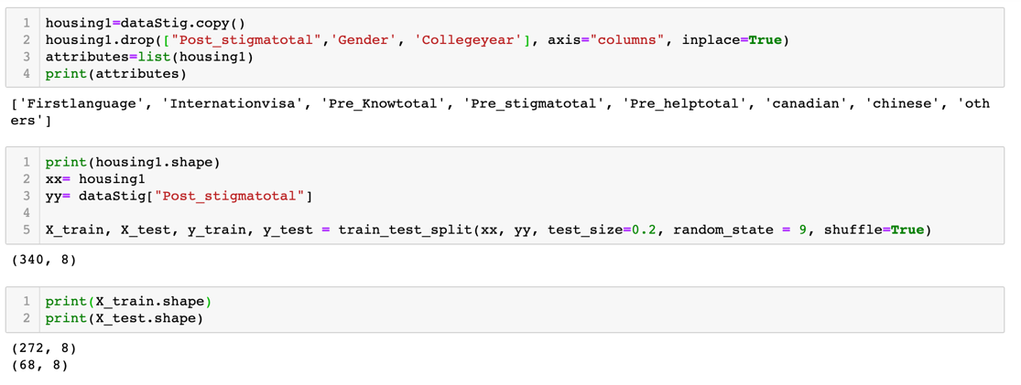

* **Fit** the polynomial regression **model** using the training data
  + **Analyzed** the **accuracy** of the model using the test data

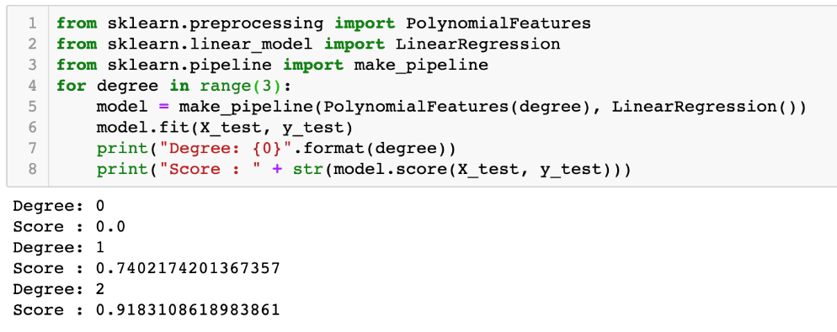

### **3.4.3. Results**

With help of supervised learning we trained a polynomial regression model with degree 2, to predict the stigma total for the students participating in the transition program using the cleaned and transformed data with an accuracy of “91.8%”.

# **Conclusion**

All the analysis was done on the basis of the data provided and various conclusions were drawn on the basis of various analysis methods. Various calculations and assumptions were made in the process that led to the above stated results.

# **References**

[1] Bluman, A. (2019). *Elementary Statistics*. 7th ed.

[2] Socscistatistics.com. (2019). *Chi Square Calculator - Up To 5x5, With Steps*. [online] Available at: https://www.socscistatistics.com/tests/chisquare2/default2.aspx [Accessed 10 Apr. 2019].

[3] Evans, J. (n.d.). *Business analytics*.